Practical – 1
Study of Python Ecosystem for Machine Learning:

Python, SciPy, and Scikit-learn.
- What is Machine Learning?
Machine Learning is the method to implement AI that enables machines to learn from the data and improve their performance without being explicitly programmed.
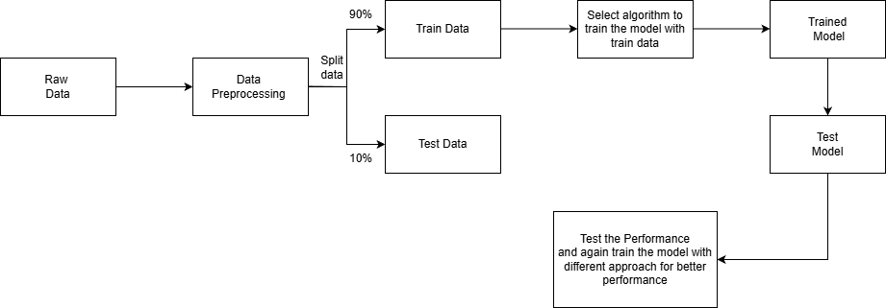
Figure: 1
Machine-Learning Workflow
- Why use Python for Machine Learning?
Python provides the core programming environment for Machine Learning applications. Its readability and ease of use enable faster development and quick experimentation. Python supports object-oriented, procedural, and functional programming, making it flexible for various ML implementations.
Key reasons Python is preferred:
- Simple and readable syntax.
- Easy integration with C/C++ for performance.
- Strong support for automation and scripting.
- Large open-source community and documentation.
- Python has large set of libraries that help developers to avoid writing code again and again and optimize their workflow like NumPy, Pandas, SciPy, Scikit-learn etc.
Python also integrates well with web frameworks and databases, making it suitable for deploying ML-based systems.

What is the use of NumPy library in Python for Machine Learning?
NumPy: Numerical Python is the backbone of numerical computation in Python. It introduces the N-dimensional array (ndarray), which enables efficient storage and processing of large datasets.
NumPy is commonly used for:
- Matrix and vector operations
- Linear algebra computations
- Mathematical transformations
- Efficient numerical calculations
Most Machine Learning libraries depend on NumPy internally, making it an essential part of the ecosystem.
Example:
import numpy as np
data = np.array([10, 20, 30, 40, 50])
print("Original Array:", data)
print("Each number + 5:", data + 5)
print("Square of numbers:", data ** 2)
print("Average value:", np.mean(data))
print("Max value:", np.max(data))

What is the use of SciPy library in Python for Machine Learning?
SciPy builds on NumPy and provides advanced scientific and mathematical algorithms required in Machine Learning. It is optimized for performance and accuracy.
Major functionalities include:
- Optimization and minimization algorithms
- Statistical distributions and tests
- Distance and similarity computations!
- Signal and image processing!
SciPy is often used in clustering, regression analysis, and optimization-based ML problems.
Example:
import numpy as np
from scipy.optimize import minimize
def my_function(x):
return x**2 + 10*np.sin(x)
result = minimize(my_function, x0=0)
print(f"The minimum value is found at x = {result.x[0]:.4f}")
print(f"The value of the function at this point is {result.fun:.4f}")

What is the use of Scikit-learn: Machine Learning Library?
Scikit-learn is a widely used Python library for implementing classical Machine Learning algorithms. It provides a consistent and easy-to-use API for training and evaluating models.
It supports:
- Supervised learning algorithms (regression, classification)
- Unsupervised learning (clustering, dimensionality reduction)
- Model evaluation and cross-validation!
- Feature scaling and preprocessing
Scikit-learn’s pipeline architecture ensures reproducibility and clean ML workflows.

Example:

import numpy as np
from sklearn.linear_model import LinearRegression

# 1. Prepare data (X must be 2D, y can be 1D)
X = np.array([[1], [2], [3], [4], [5]])
y = np.array([3, 5, 7, 9, 11])

# 2. Initialize the model
model = LinearRegression()

# 3. Train the model (find the pattern)
model.fit(X, y)

# 4. Make a prediction for a new value (e.g., x = 10)
prediction = model.predict([[10]])

print(f"Prediction for x=10: {prediction[0]}")
print(f"Learned Formula: y = {model.coef_[0]:.0f}x + {model.intercept_:.0f}"

What is the use of Pandas library in Python for Machine Learning?
Pandas help in:
- Loading and cleaning datasets
- Handling missing values
- Data filtering and transformation
- Exploratory data analysis
Its seamless integration with NumPy and Scikit-learn makes it a core ML tool.
Example:
import pandas as pd
data = {
'Name': ['Alice', 'Bob', 'Charlie', 'David'],
'Age': [25, 30, 35, 40],
'City': ['New York', 'London', 'Paris', 'London']
}
df = pd.DataFrame(data)
london_residents = df[df['City'] == 'London']
average_age = df['Age'].mean()
print("Full DataFrame:\n", df)
print("\nLondon Residents:\n", london_residents)
print(f"\nAverage Age: {average_age}")

Matplotlib and Seaborn: Data Visualization
Visualization plays an important role in understanding datasets and model behavior. Matplotlib is the base plotting library in Python, while Seaborn builds on it to provide enhanced statistical visuals.
These libraries are used to:
- Visualize data distributions.
- Analyze correlations.
- Plot learning curves.
- Display confusion matrices and results.
Visualization improves interpretability and debugging of ML models.

Example:
import matplotlib.pyplot as plt
import numpy as np
x = np.linspace(0, 10, 100) # 100 points between 0 and 10
y = np.sin(x)
plt.figure(figsize=(8, 4))
plt.plot(x, y, label='Sine Wave', color='blue', linestyle='--')
plt.title("My First Colab Plot")
plt.xlabel("Time")
plt.ylabel("Amplitude")
plt.legend()
plt.grid(True)
plt.show()

Google Colab
Google Colaboratory (or "Colab") is a free, cloud-based platform that allows you to write and run Python code in your browser. It is essentially "Google Docs for programmers," built on the open-source Jupyter Notebook standard.
- Key Features
- Zero Configuration: You don’t need to install Python or manage environments on your computer. Everything is pre-configured in the cloud.
- Free GPU/TPU Access: Provides free access to powerful hardware like NVIDIA T4 GPUs and Google’s TPUs, which are essential for training AI and machine learning models.
- Seamless Collaboration: Share notebooks via a link, allowing multiple people to comment on or edit the same code in real-time, just like a Google Doc.
- Google Drive Integration: Notebooks are automatically saved to your Drive. You can also mount your Drive to access your personal datasets directly.
- AI Coding Assistance: Features built-in AI (Gemini) to help you generate code, fix errors, and explain complex blocks of script.
- Pre-installed Libraries: Popular data science libraries like NumPy, Pandas, Matplotlib, TensorFlow, and PyTorch are ready to use immediately.

- How It Works
- The Notebook Environment: Your work is organized into "Cells."
- Code Cells: Where you write executable Python.
- Text Cells: Where you write explanations using Markdown or math equations using LaTeX.
- Cloud Runtimes: When you press the "Play" icon on a cell, your code isn't running on your laptop. Instead, it is sent to a Virtual Machine (VM) in Google’s data centers.
- The Lifecycle: * Once connected, you are assigned a temporary VM with its own RAM and disk space.
  - Sessions are temporary. If you are inactive for too long (or after 12–24 hours), the VM is recycled, and any unsaved local files are deleted (which is why saving to Google Drive is standard).
- Hardware Switching: You can switch between a standard CPU and a powerful GPU by going to Runtime > Change runtime type.

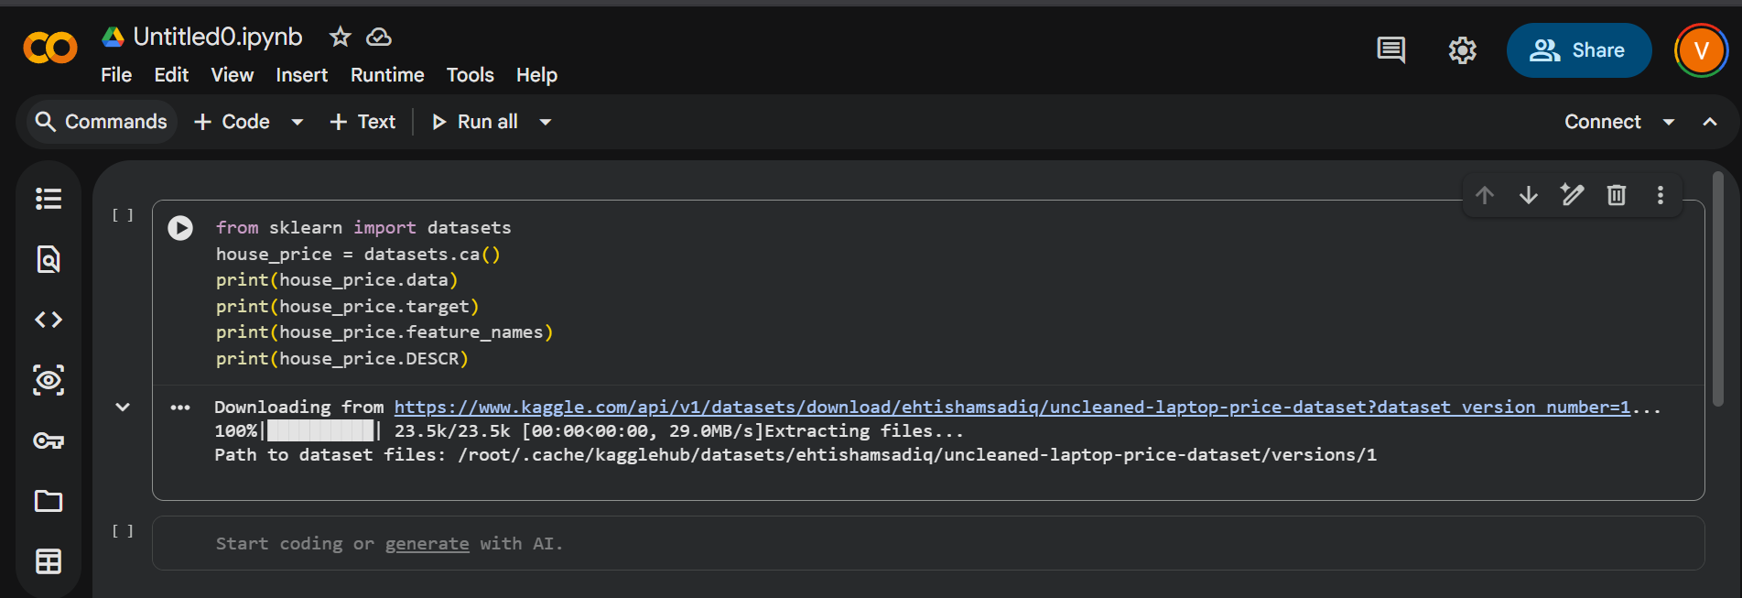
Figure: 2
Google Colab

Conclusion
The Python ecosystem offers a complete environment for Machine Learning, covering data preprocessing, algorithm implementation, visualization, and deployment. Python, along with NumPy, SciPy, and Scikit-learn, forms the foundation of traditional ML workflows.
Supporting libraries such as Pandas, Matplotlib, SciPy, Scikit-learn, and Google colab enhance Python’s capabilities across different ML domains. Due to its flexibility, scalability, and rich ecosystem, Python continues to be the preferred language for Machine Learning.

